**Assessment No 1**

Section 1:

1. Write a query to display:

a. Employee Name and Manager name (employee’s manager)

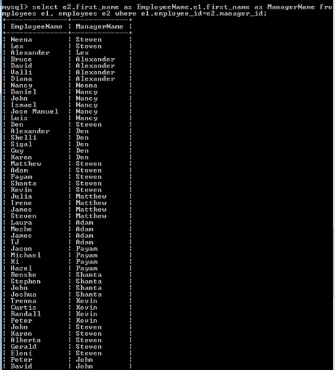

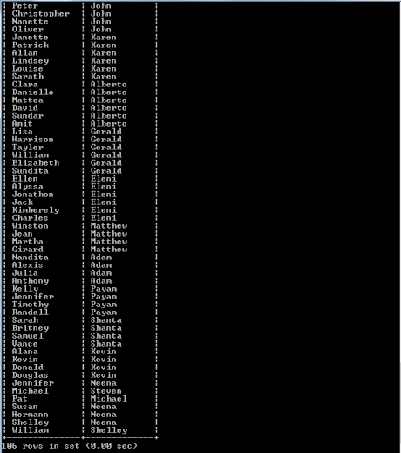

b. Employee Name and Department Name (the employee belongs to)

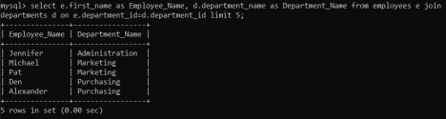

c. Country name and region name (country belongs to)

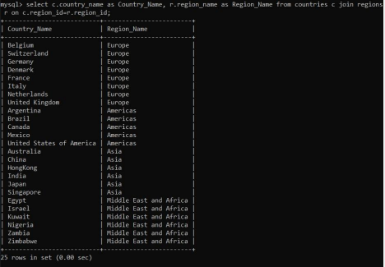

2. How many countries fall under a region, write a query to display the region and total countries in that region.

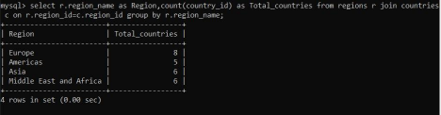

3. Write a query to display:

a. Which department draws maximum salary?

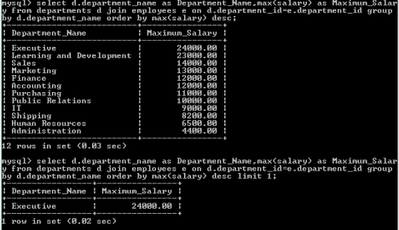

b. List highest paid employees in each department?

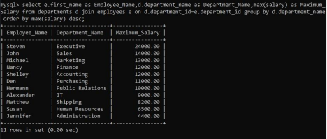

c. To which country the following departments belong?

i. Administration

ii. Executive

iii. Manufacturing

iv. Government Sales

v. Recruiting

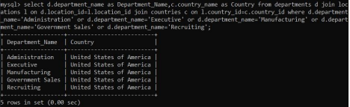

4. Pratik has joined the company recently into a new department ‘Learning and Development’ as manager. Make necessary updates in the database tables and insert the record. Assume necessary data.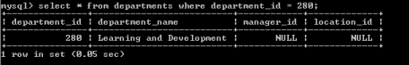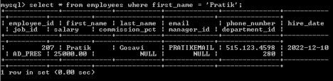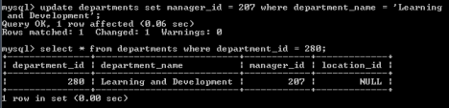

Q.2) Use the below data set, to answer the following questions using SQL.